San Jose State University

EE250 (Section 2) Fall 2019 Prof. Kamali

Solution to Problem Set #8

- Problem 9.5
a) For 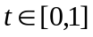 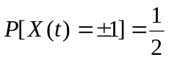
For 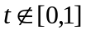 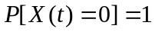

b) 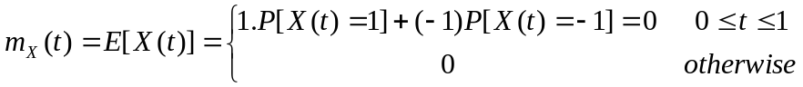
c) For , 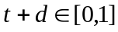
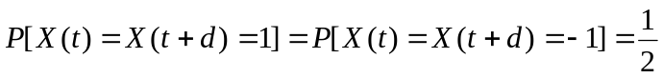

For , 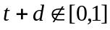
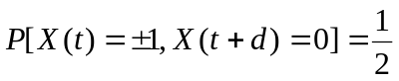

For ,
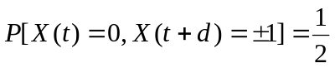

For ,
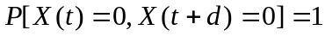

d)

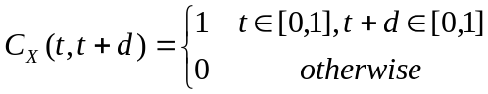

- Problem 9.26
a) 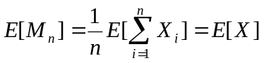
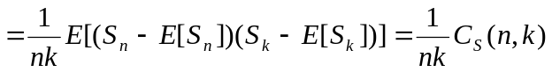

where is the sum process and so 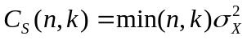 (equation 6.29) which leads to

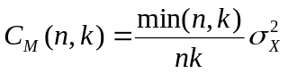
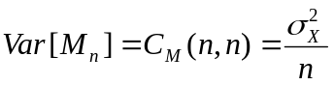

b) 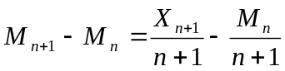

Clearly 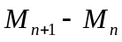depends on 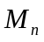 and so they are not independent which means process does not have independent increments.

Also depends on which indicates that the increment’s distribution changes by time and so process does not have stationary increments.

- [Final Exam, Spring 2008] The random process is defined as follows where  and are two independent uniform random variables between 0 and 1 and 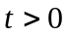.

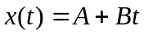

- Find and plot the pdf of (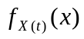).
- Find the range of where 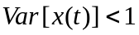.

Solution:
- The pdf of and 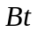are as follows.

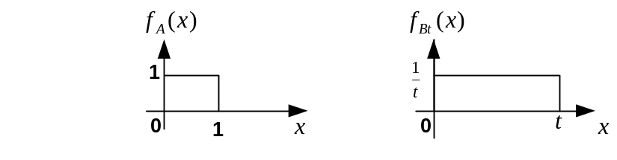

Since they are independent, the pdf of will be the convolution of the above two pdf’s as follows.

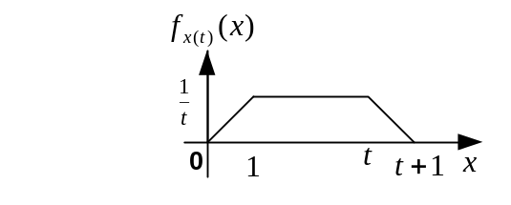

- Since and are independent,

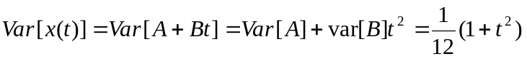

- [Final exam, Spring 2014] Consider the random process 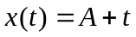 where is uniform in the interval [-1,1]. Find the pdf of 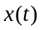.

Solution:

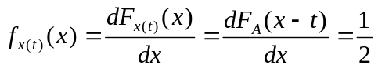

for 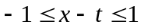 or 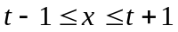.

Thus also has a uniform distribution in the interval 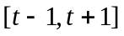.

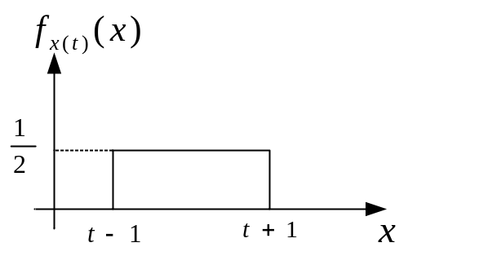

- [Final Exam, Fall 2005] Suppose 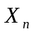 is an iid sequence where 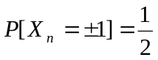. Find the mean and auto-covariance of 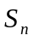defined as follows.

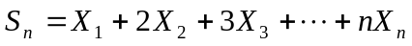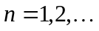

Hint: 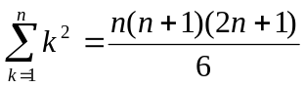

Solution:
Clearly 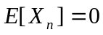 and 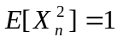.

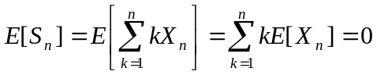

Since ’s are independent, we have

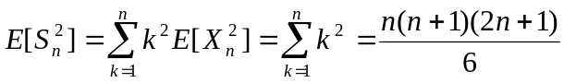

If ,

We note that 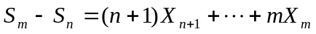has no common term with and as such they are independent. Thus

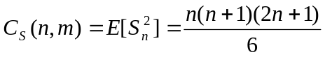

In general
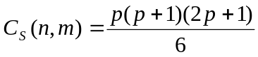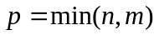

- [Final exam, Spring 2014] Consider the sum process 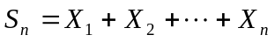 where 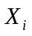's are iid and 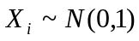 for 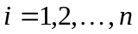. Find 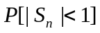.

You should write the answer in terms of Q function.

Solution:
is the sum of Gaussian distributions and so it is Gaussian.
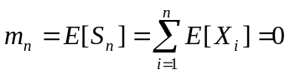
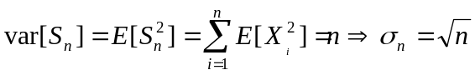

- [Final Exam, Fall 2009] Suppose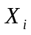’s are iid (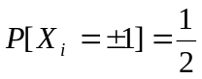 for 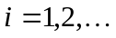) and 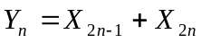 (). We define the discrete time random process as follows.

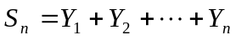

Find 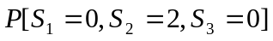.

Solution:
We note that 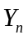’s are also iid with the following pmf which is found through convolution of the pmf of with itself.

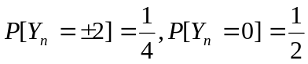

Therefore is a sum process which has the stationary and independent increment property.

where we used 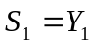 in the very last step.

- [Final Exam, Fall 2009] Suppose’s are iid with uniform pdf between 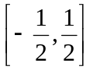 and

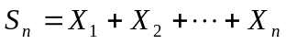

Find 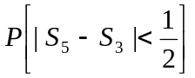.

Solution:
Due to stationary and independent increment property of the sum process, we have

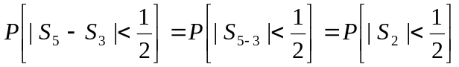

The pdf of 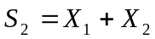 can be found by convolving the pdf of 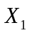 and 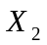which are the same. It is easy to see that the result is the following triangular function.

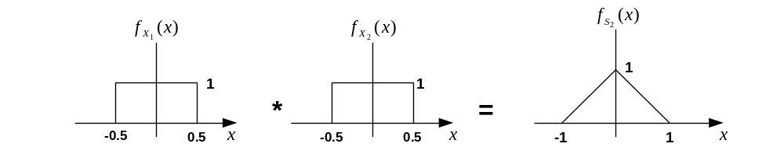

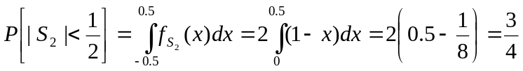

- [Final exam, Fall 2015] Consider the discrete-time random process and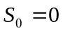 where 's are iid with Bernoulli distribution (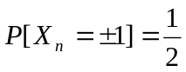). Find 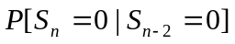.

Hint: 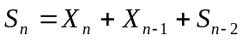

Solution:

Thus

where we have used the independence of 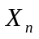 and 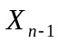.
- [Midterm, Fall 2017] Assume  is an exponential random variable with mean 1 (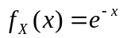for 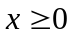) and 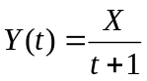 for 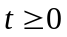. Find the pdf of 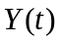.

Solution:

Clearly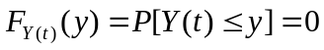 for 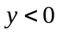.

For 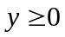, 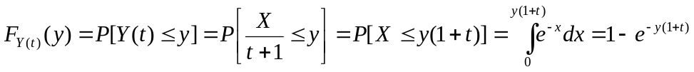

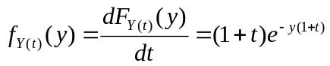

- [Final exam, Fall 2017] Consider the discrete-time random process where 's are iid with Bernoulli distribution (). Find 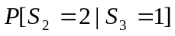.

Hint: 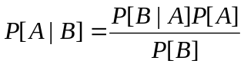

Solution:

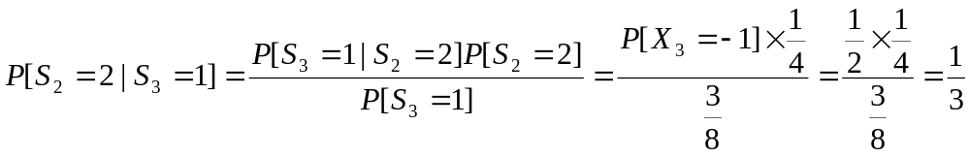

where we have used the following equations.

